Improved Web Design using CSS/Bootstrap

LAB # 03



Spring 2024
CSE-403L Database Management Systems Lab

Submitted by: Ali Asghar
Registration No.: 21PWCSE2059
Class Section: C

“On my honor, as student of University of Engineering and Technology, I have neither given nor received unauthorized assistance on this academic work.”

Submitted to:
Engr. Sumayyea Salahuddin

Date:
23rd April 2024

Department of Computer Systems Engineering
University of Engineering and Technology, Peshawar
Objectives:
This lab aims at the understanding of:
- The concept of Dynamic HTML
- Cascaded Style Sheets (CSS)
- Various attributes of CSS such as font, color, background, text, border, margin, and list
- User-Defined Selectors including Class and ID
- Span and Div Tags
- External Style Sheets and their benefits.

Task 3.1:
1. How Dynamic HTML can be helpful for a SQL/NoSQL database? Write a short note on the paper.
Ans: DHTML refers to a combination of technologies used to create interactive and dynamic web pages. It includes HTML, CSS, and JavaScript. DHTML allows web developers to manipulate the content and behaviour of web pages dynamically, enhancing user experience and interactivity.
DHTML enables real-time updates and dynamic content rendering on web pages. For databases, this means displaying live data without requiring page reloads.
- SQL databases can benefit from DHTML by showing real-time query results or updating records instantly.
- NoSQL databases can use DHTML to display unstructured data in a more user-friendly format.

2. Hands-On: Understand and go through all the examples provided in this lab. Try each one in your favorite IDE. Check output in browser and try to make some changes from your own.
Example 1:
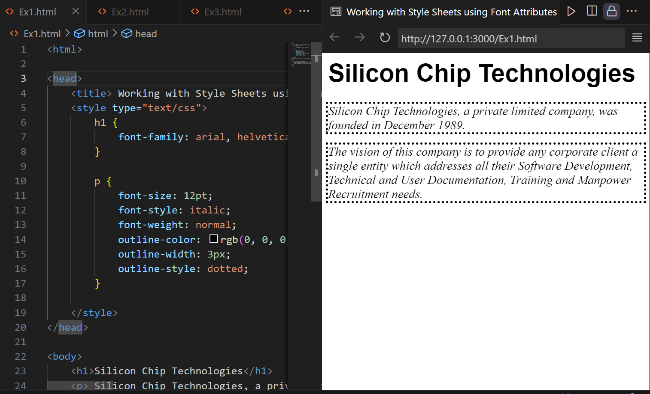

Example 2:
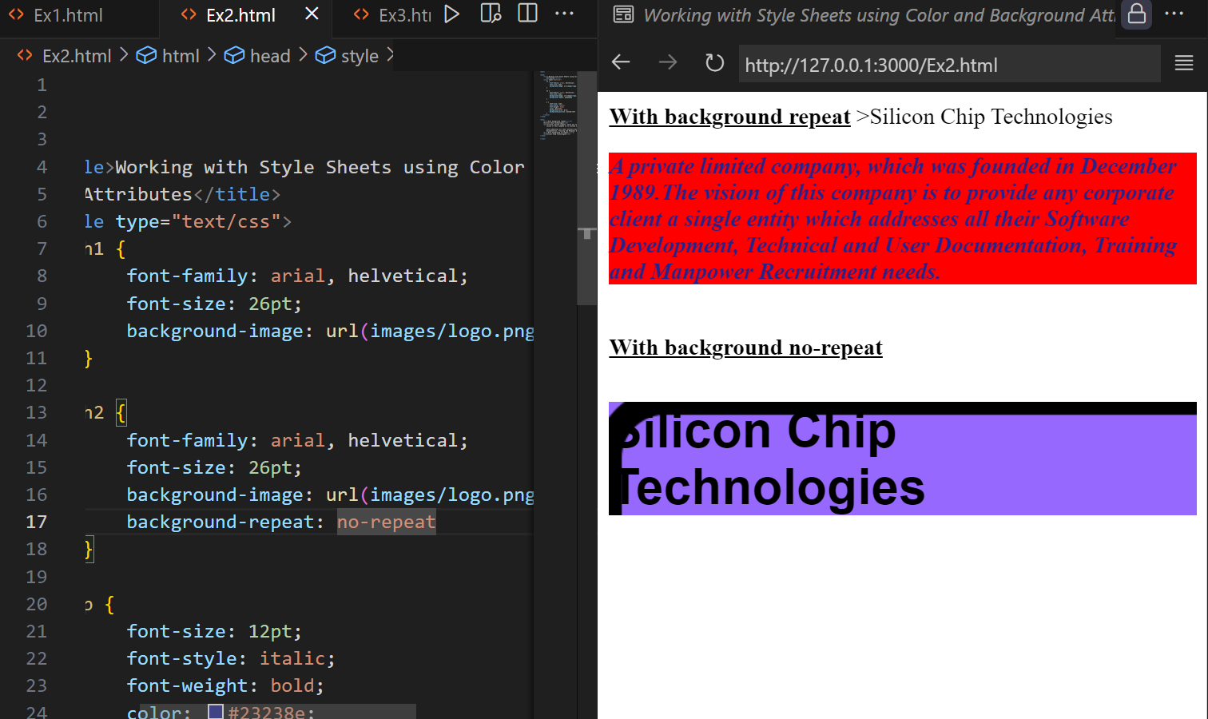

Example 3:
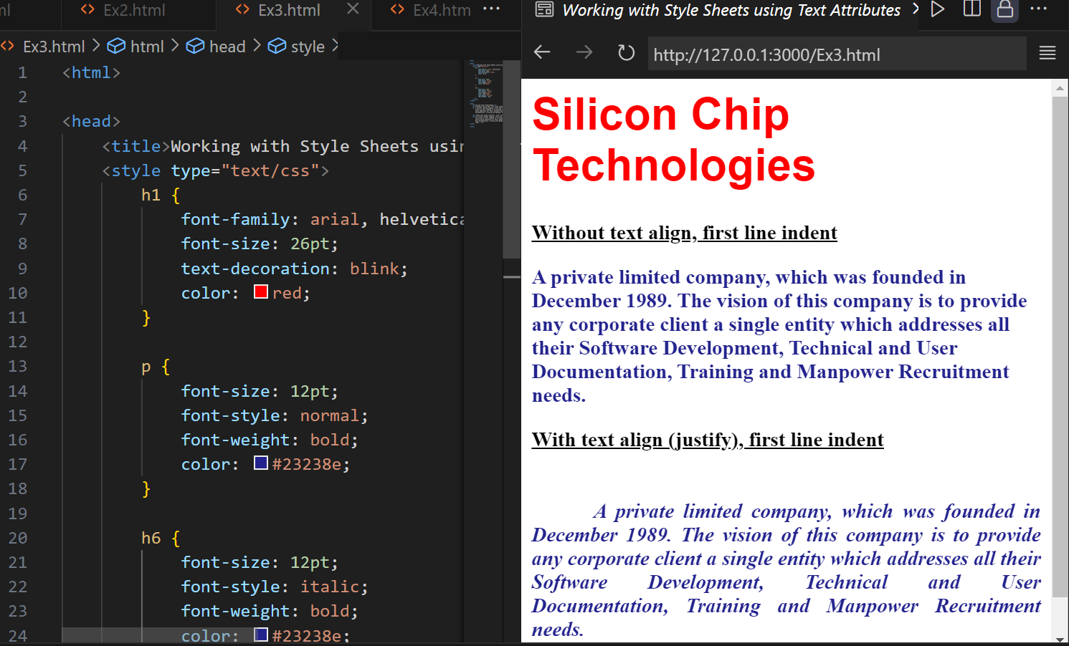

Example 4:
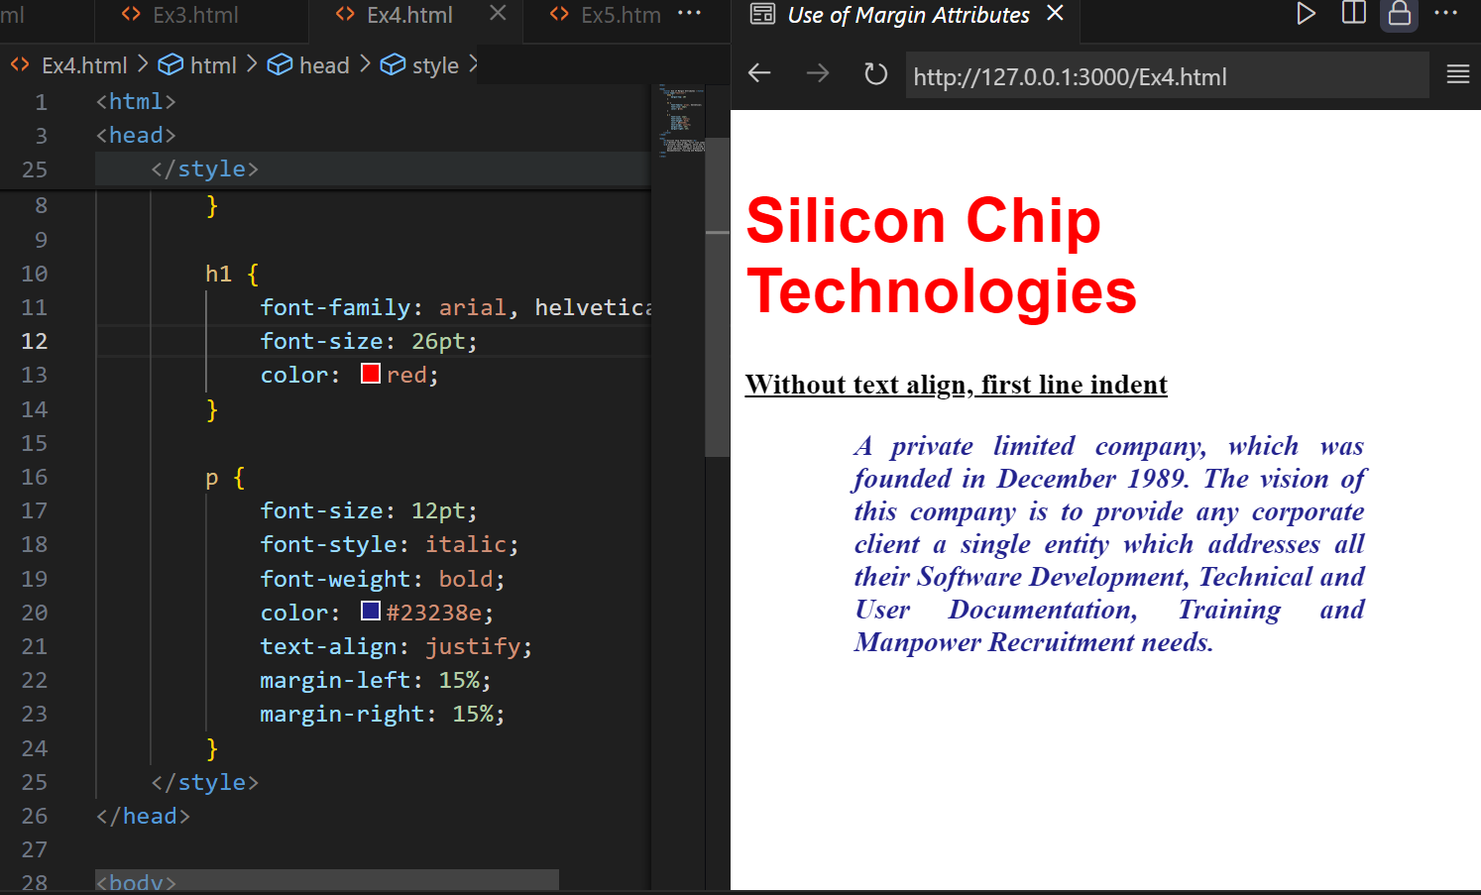

Example 5:
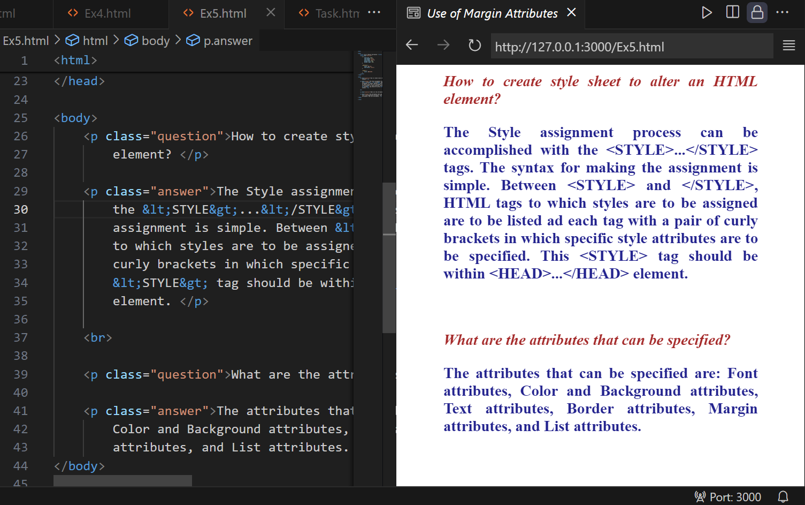

Example 6:
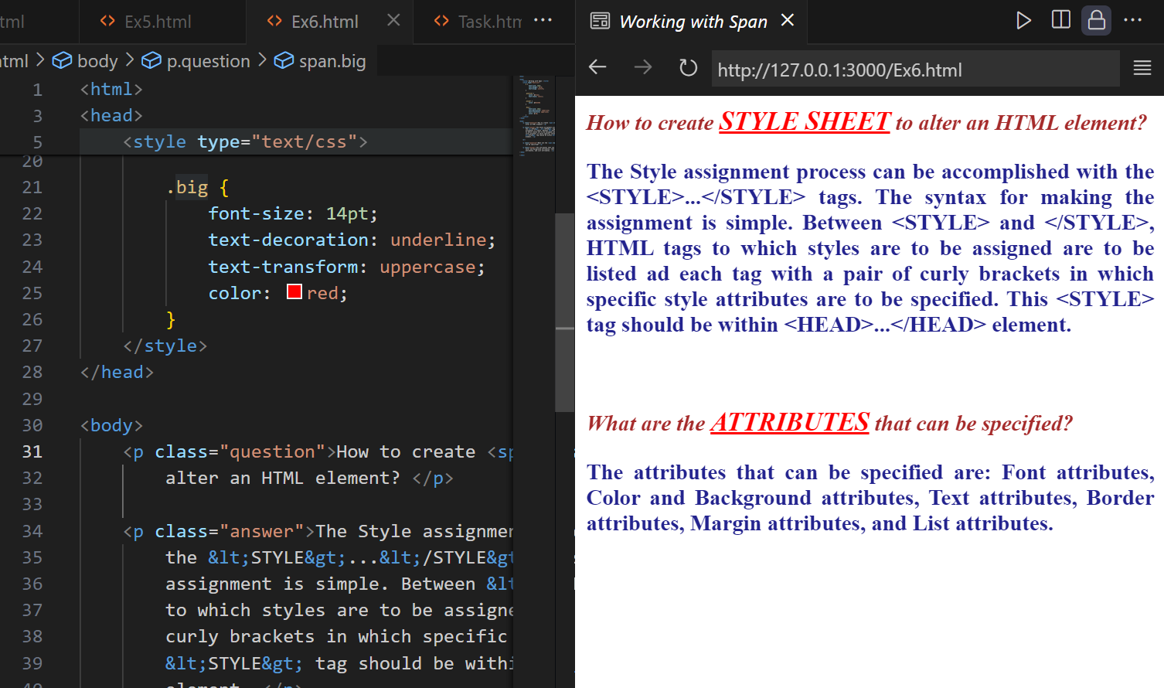

Example 7:
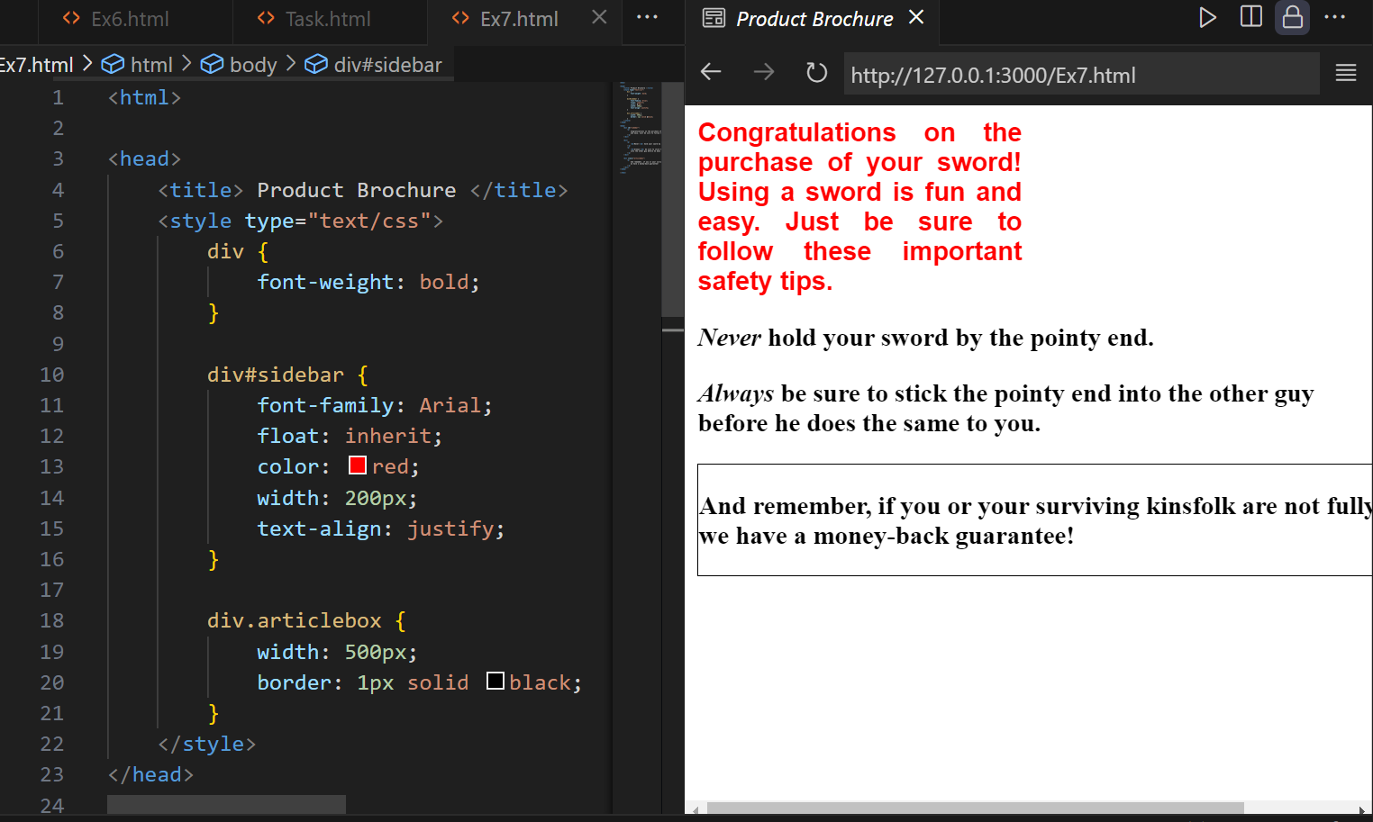

3. Hands-On: Write the HTML code that generates the output web page shown in Figure 3.8 with following specification:
a) Heading 1 has font value of Arial and Helvetica, size 26 pts, and red color.
b) Each paragraph is 12 pts, bold, and italic. Take paragraph color value: #23238e
c) Use groove border style and thick border width.
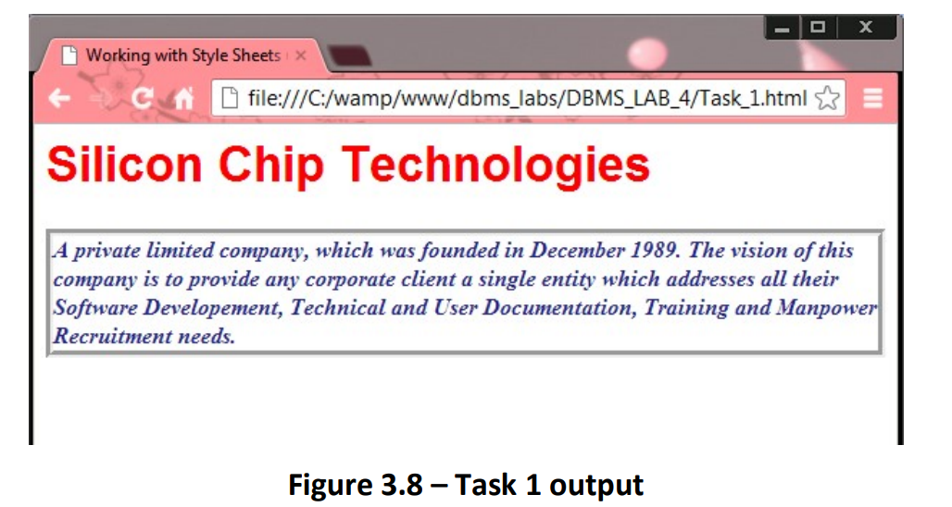

Code:
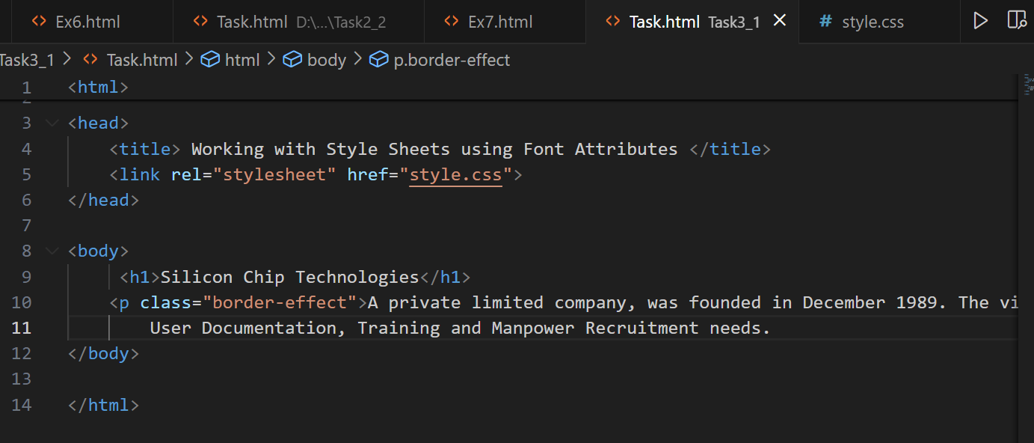
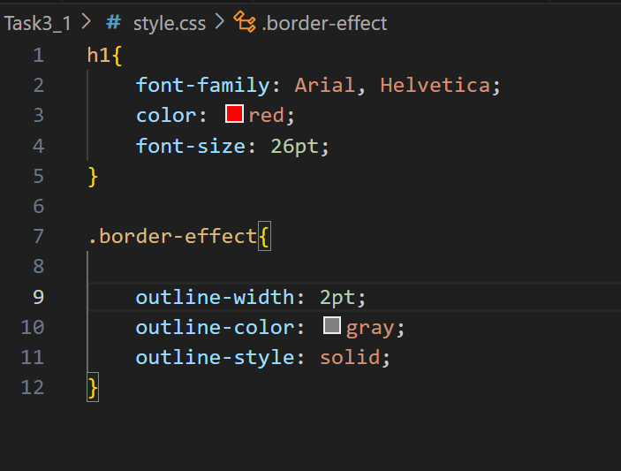

Output:
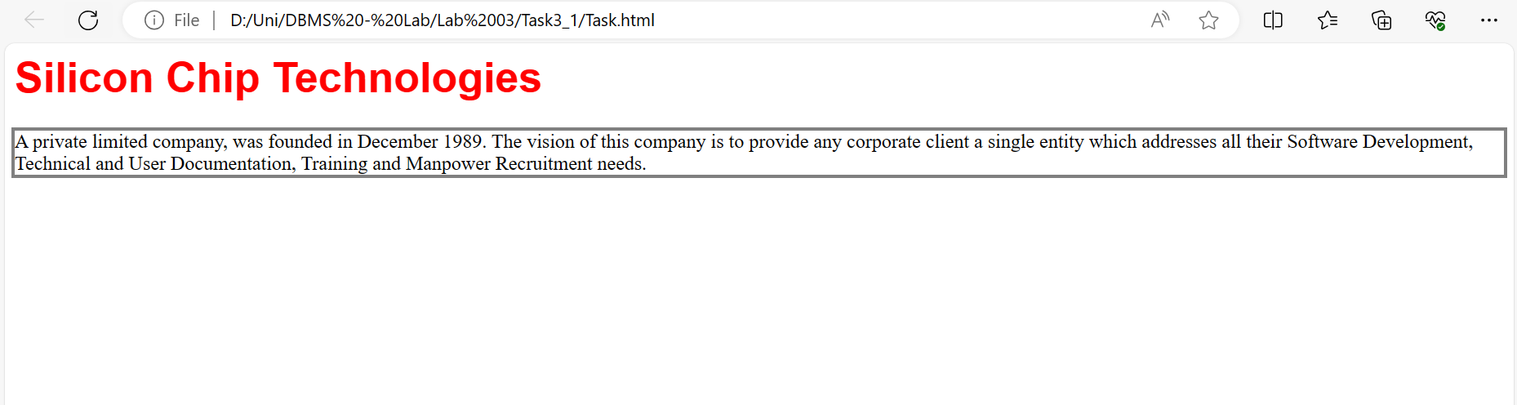

4. Evaluate yourself and write a note about your understanding of this lab.
Ans:

Task 3.2:
Code:
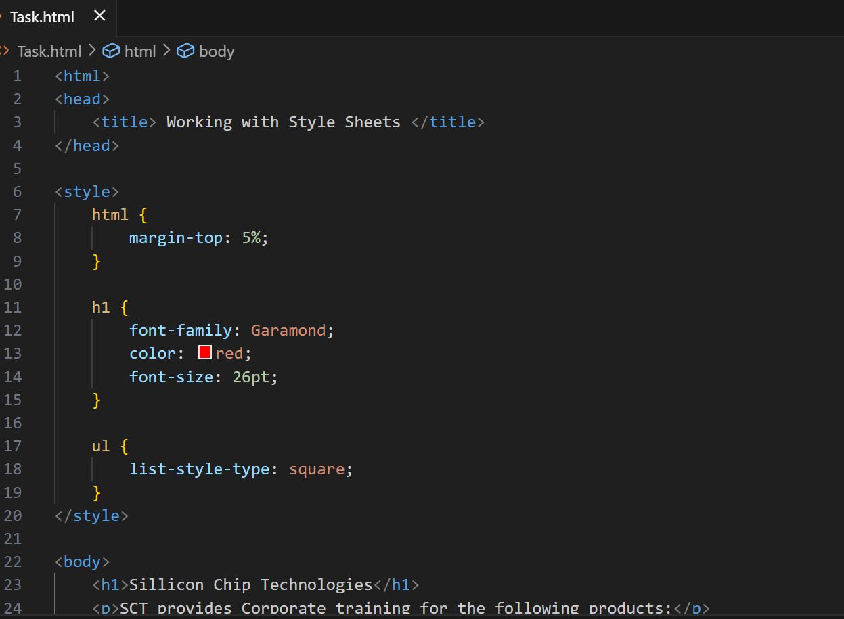
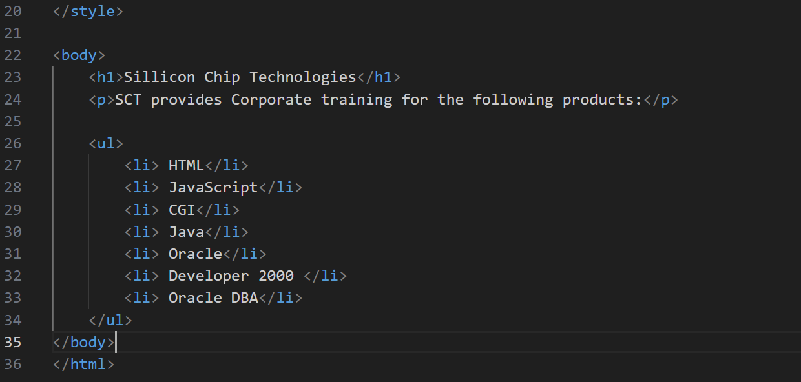
Output:
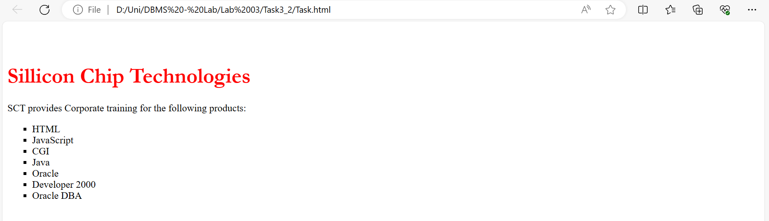

Task 3.3:
Code:
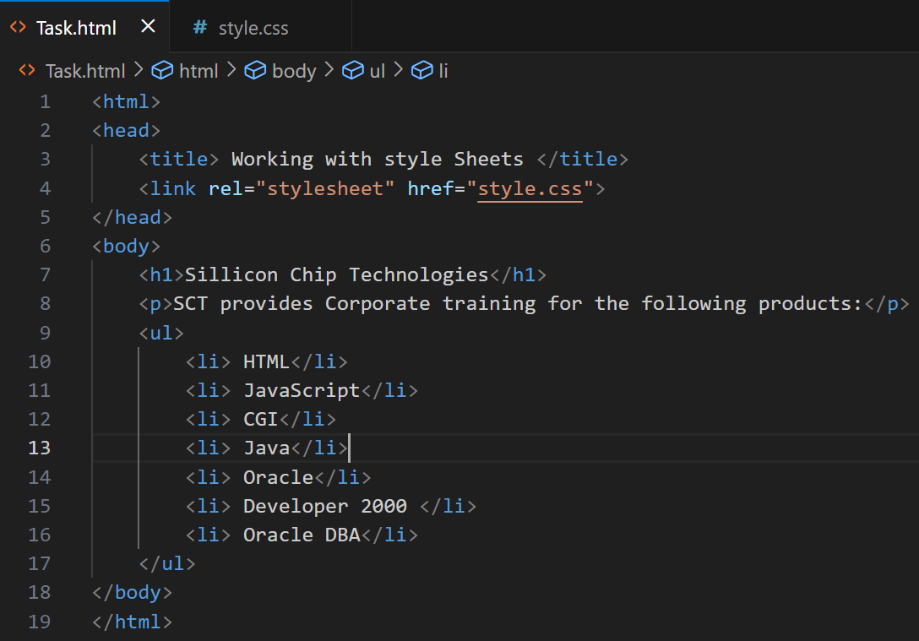

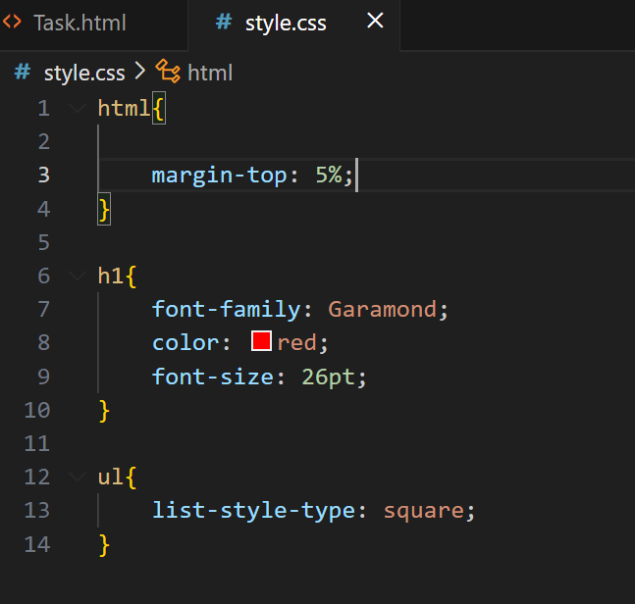

Output:
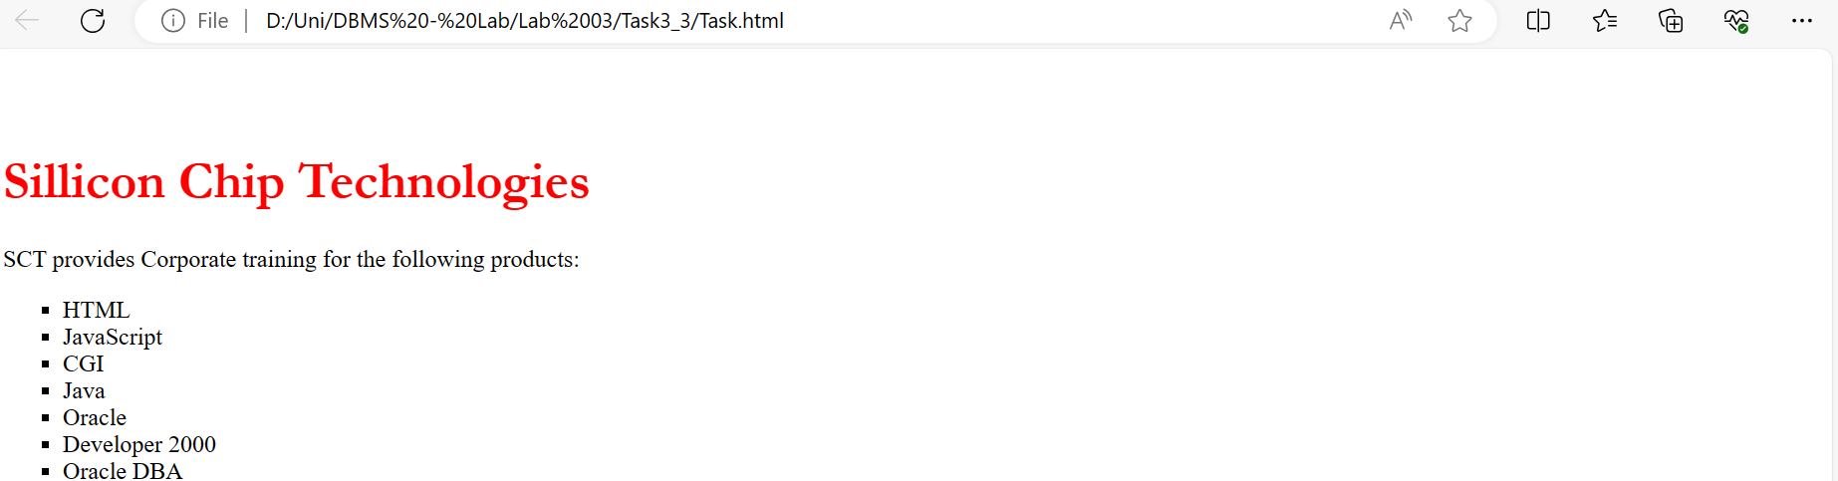

Task 3.4:
Code:
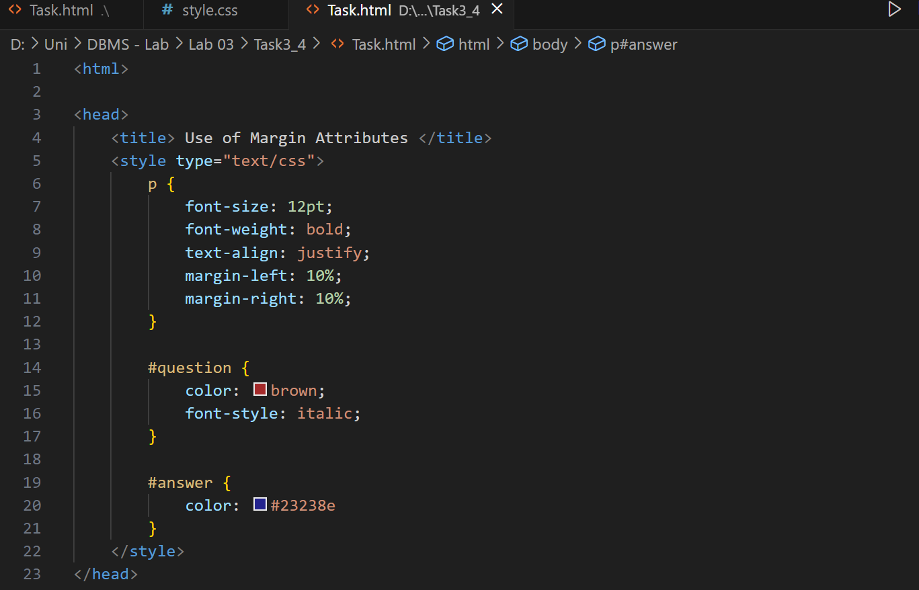
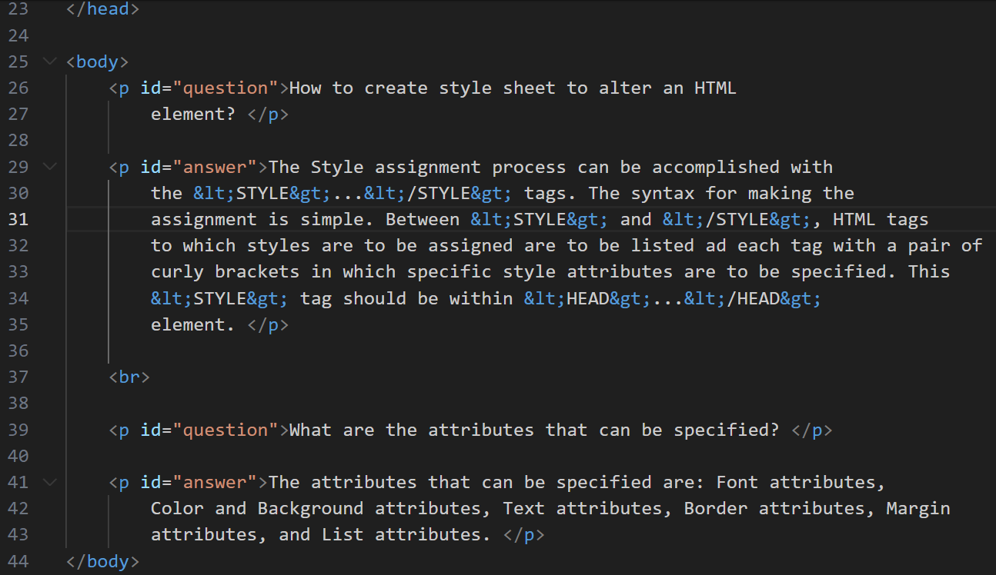

Output:
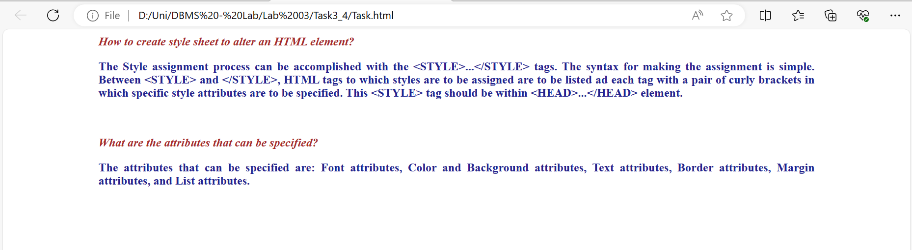

Task 3.5:
Changes Done:
I changed each demo for a different application.
Sign-In Demo: I changed it as a sign-in page of game making company. I added its logo and some other changes as well.
Cover Demo: I changed it as a cover page for a computing company by name of parallel computing.
Checkout Demo: I changed it for a company by name of Electronic Fellows and add some items related to the online electronic shop.
Blog Demo: In this demo, I did minor changes.

Output:
Sign-In Demo
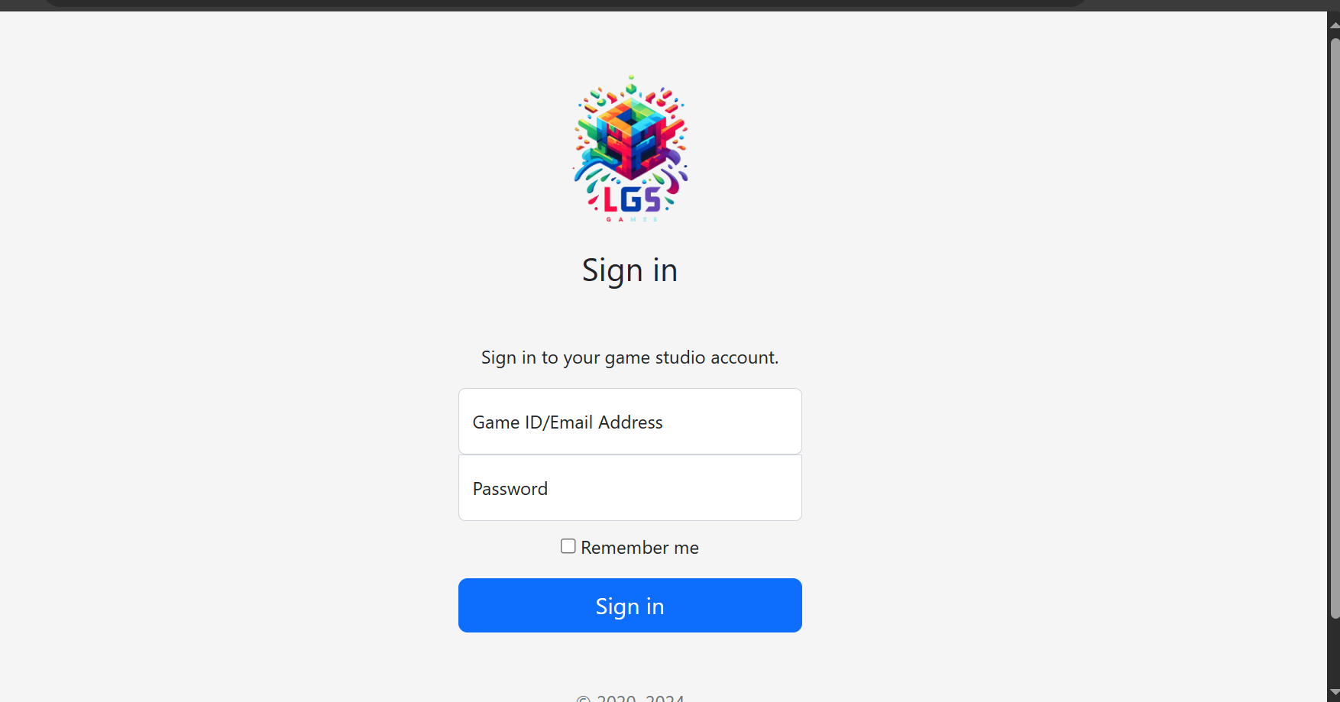

Cover Demo


Checkout Demo
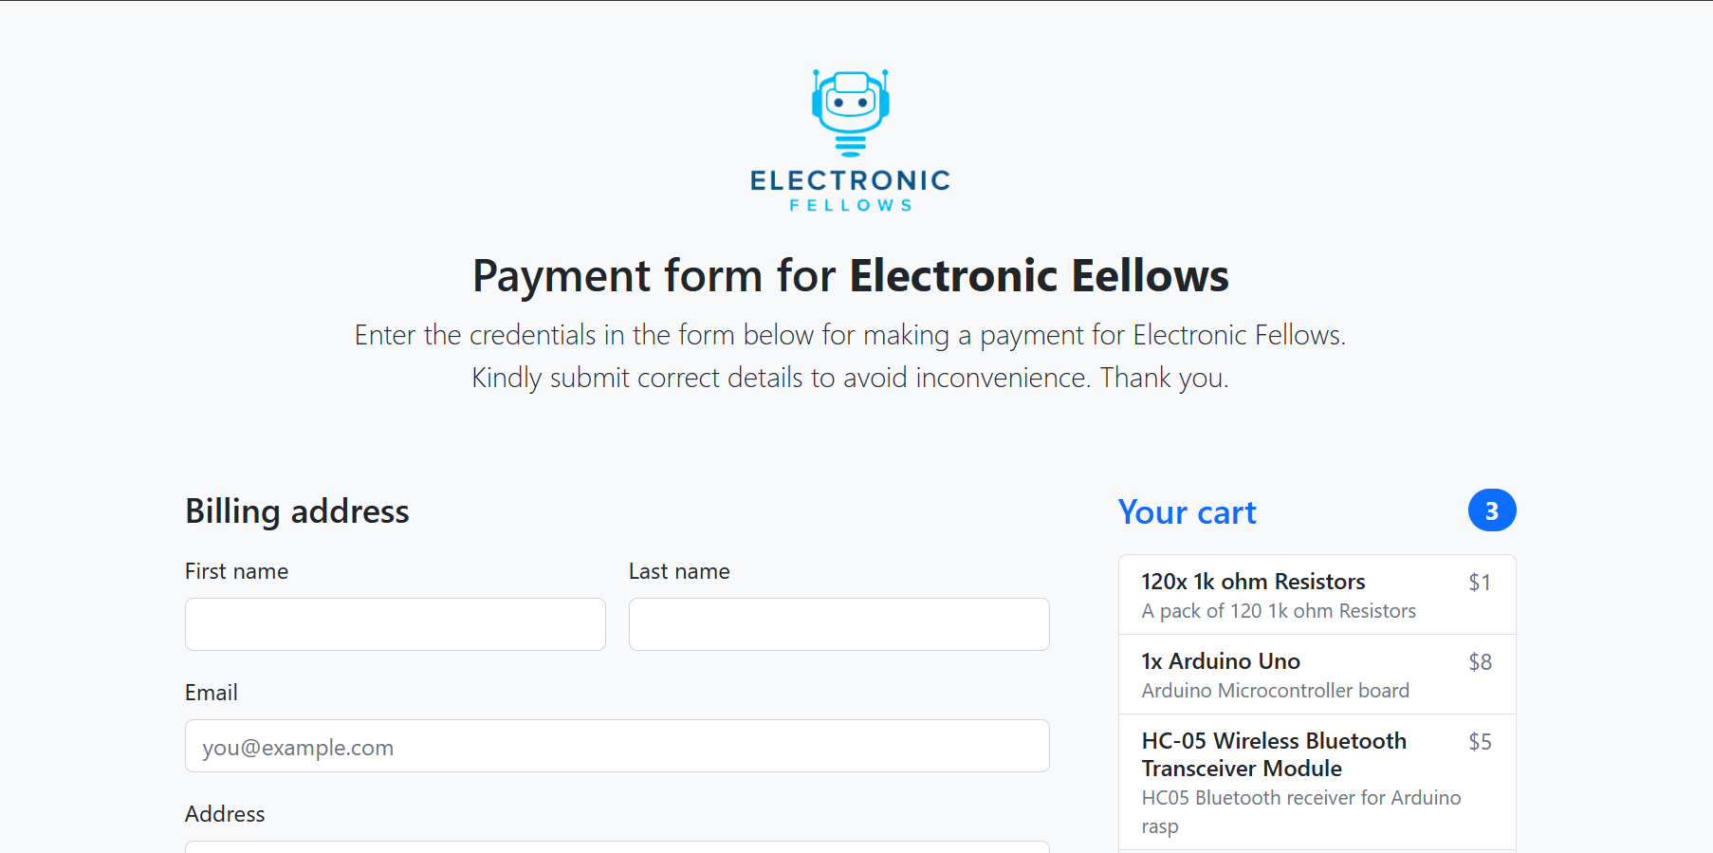

Blog Demo
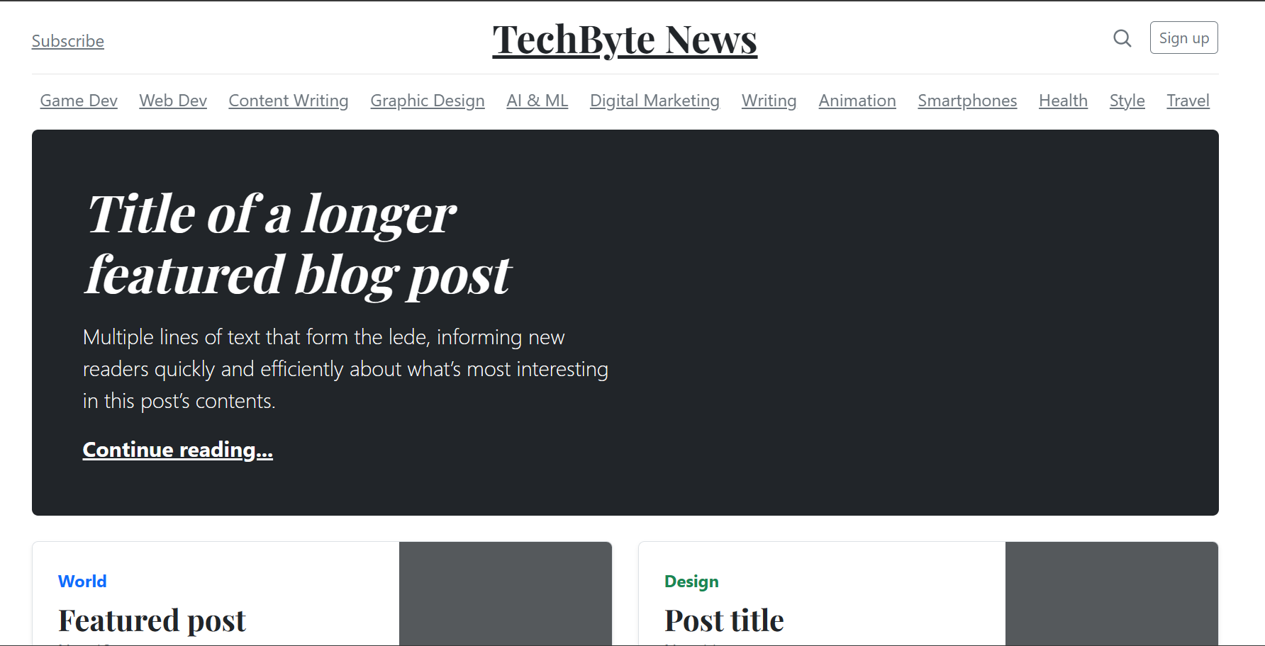

Task 3.6:
Code:
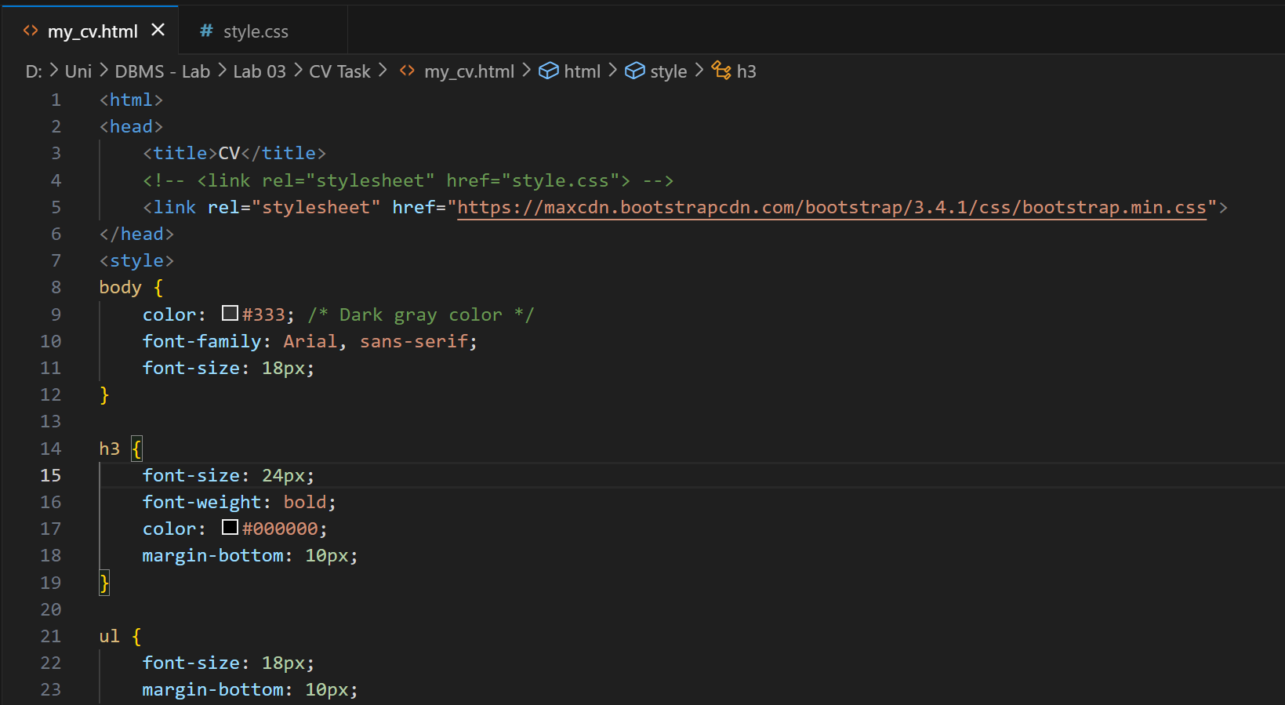
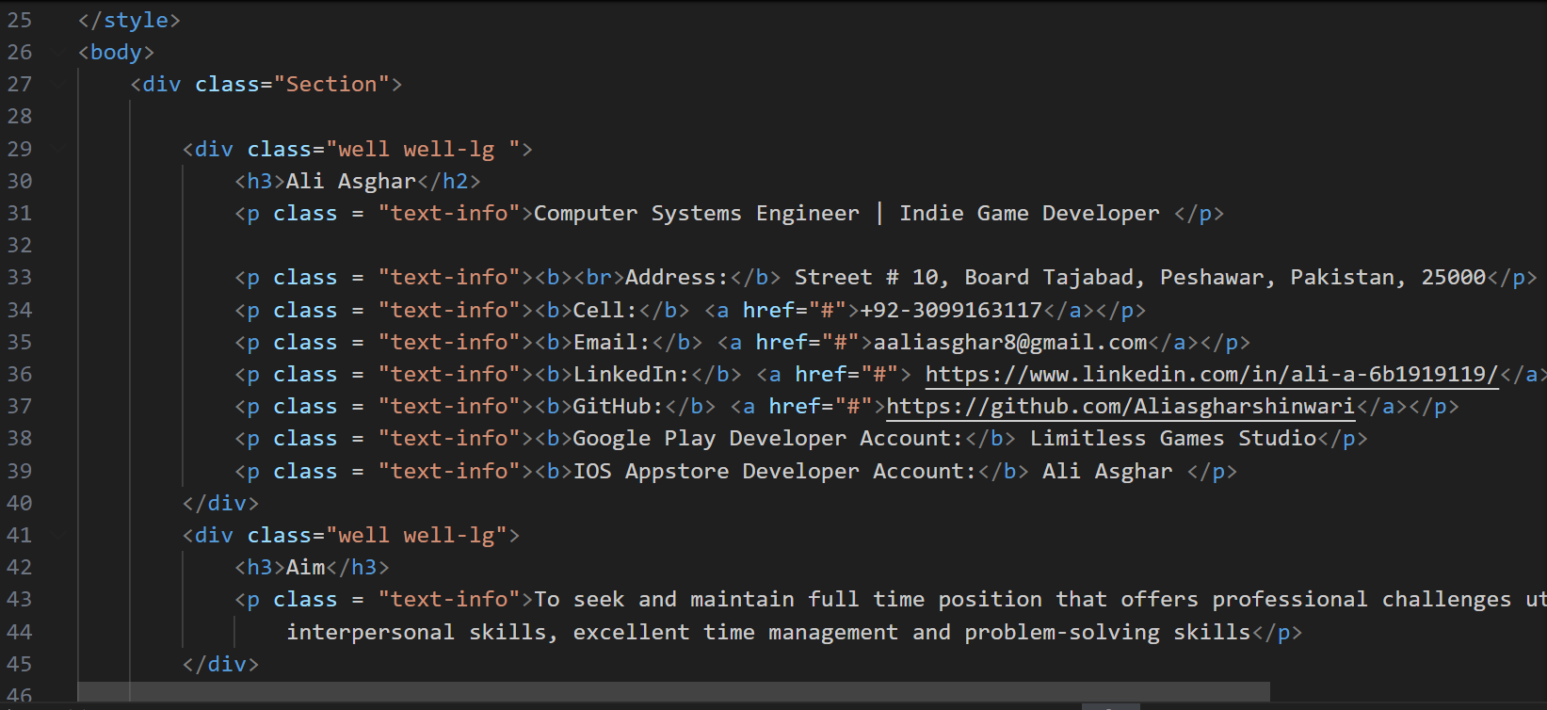
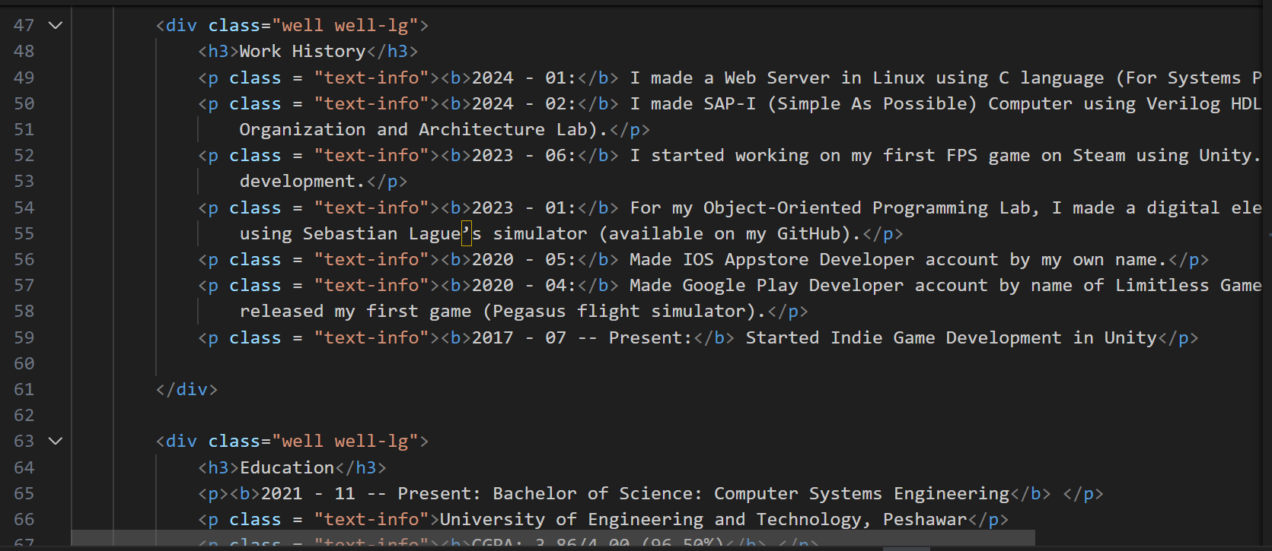
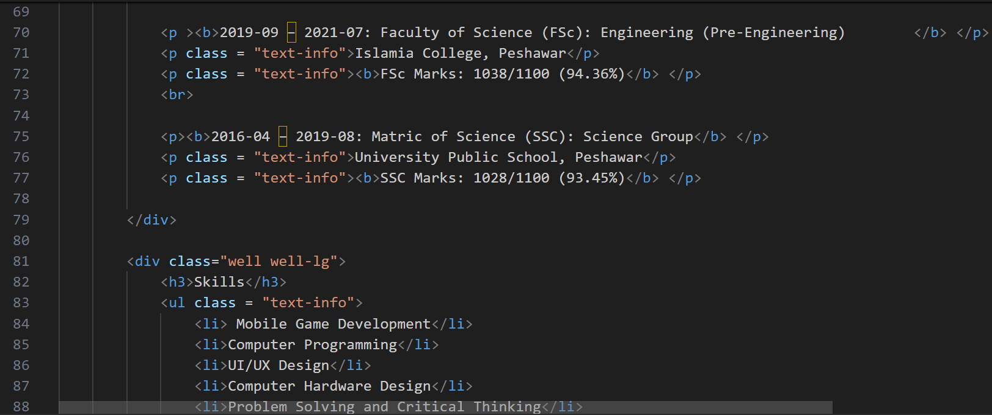
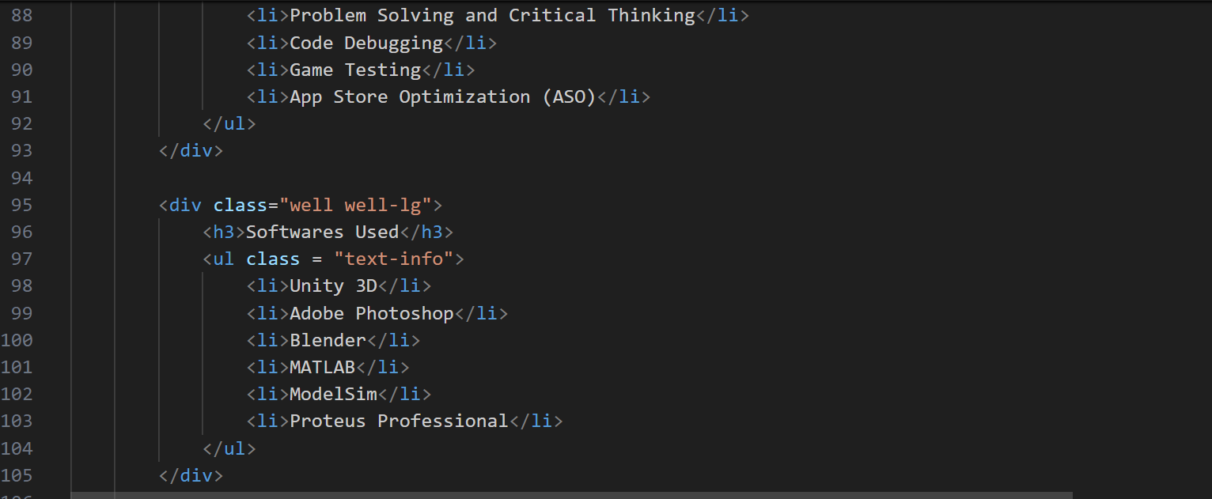
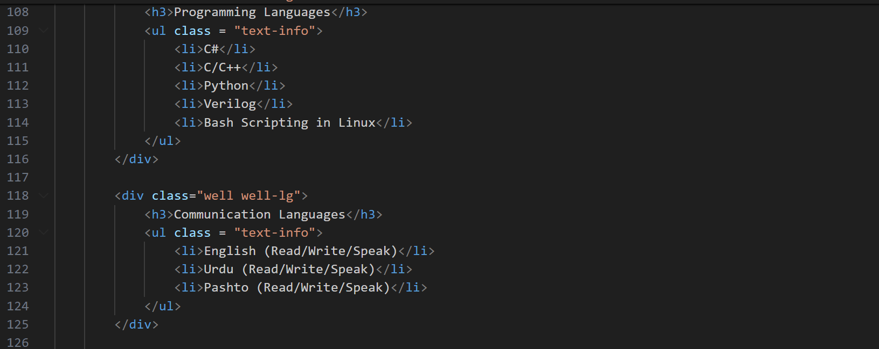
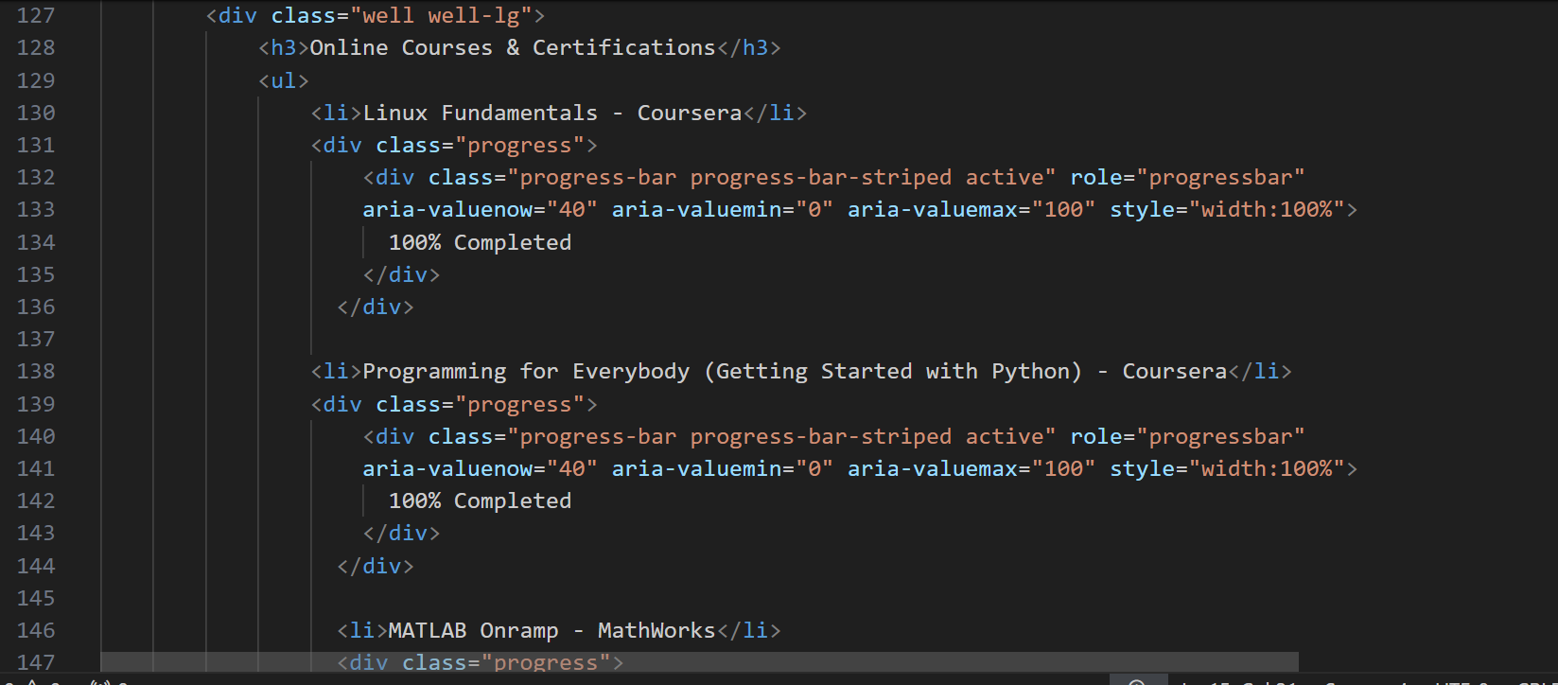
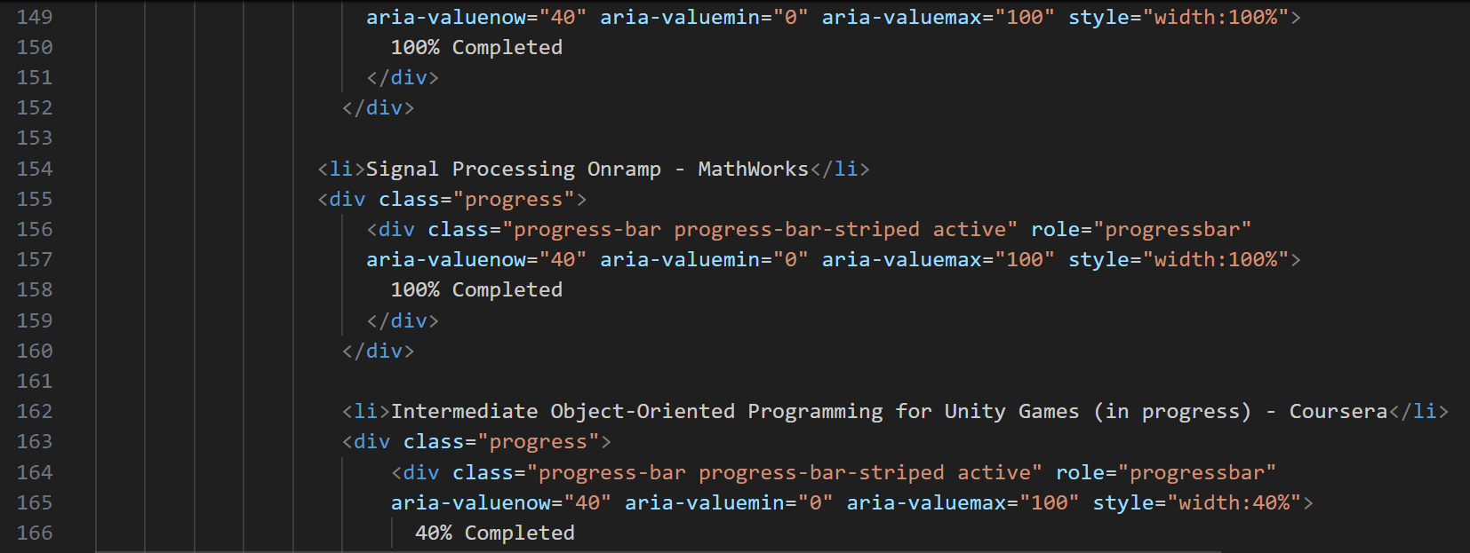
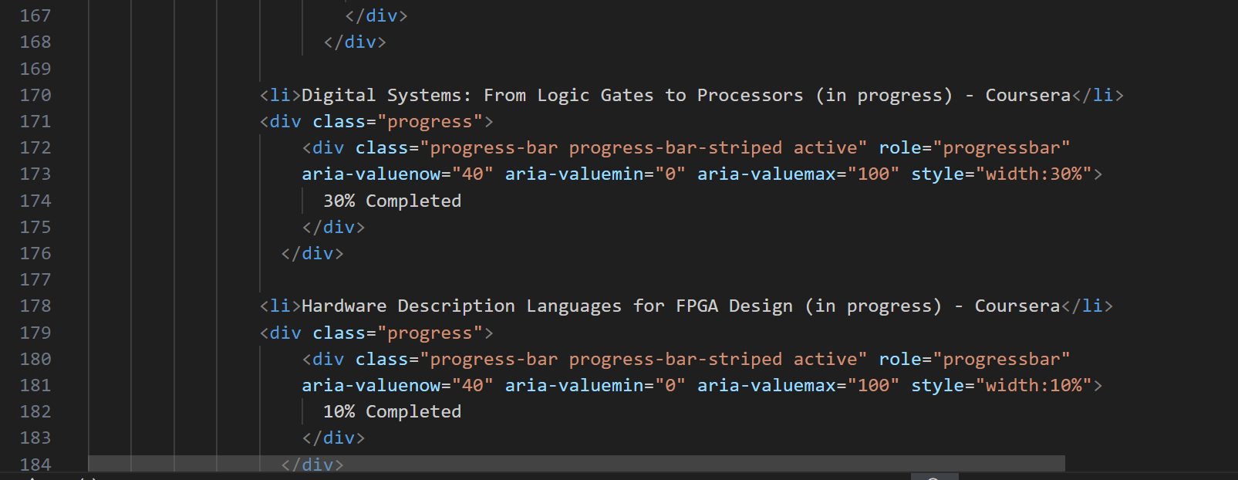
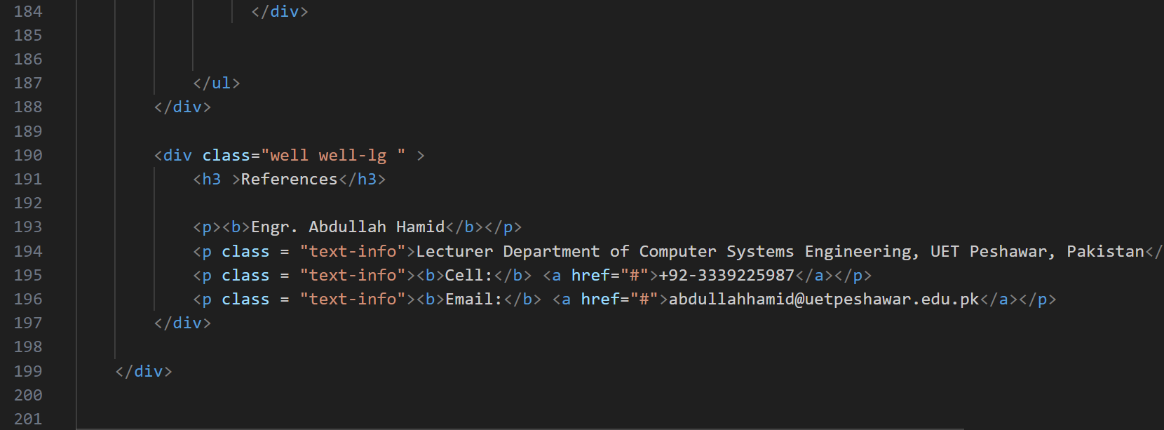
Output:
